 PTA NEWS
Thank you Coal Creek Elementary families for making our 2022 Jogathon Fundraiser successful. I am, as ever, amazed at the level of support and generosity our community demonstrates. WE MADE IT! $40,000 towards academic, enrichment, and community needs. Check out some important information below, and if you have any questions contact your friendly PTA Board at coalcreekelementarypta@gmail.com. - Liz |   Check out this  Silent Disco  Video  from Big Heart Film

CCE SILENT DISCO TONIGHT 10/7 7 - 11 PM STEINBAUGH PAVILION 21+
Tickets $20 at Eventbrite or pay at the door.
Join 60+ CCE parents for this event that features 3 DJs (each with a different playlist you can switch between for maximum listening and dancing pleasure) and a cashless bar serving: Crystal Springs Blood Orange Kolsh, Rock Bottom Brewery Falcon IPA, Rock Bottom Brewery Rocktoberfest, Chardonnay, Cabernet Sauvignon, Hard Seltzer, Soda, Sparkling Water, and complimentary snacks.

  VOLUNTEER Opportunities
  Bring in Snacks, Drinks, Desserts for Parent/Teacher Conferences week of 10/10. Sign Up Here.
  ---------------------------------------------------------------------
  
  Get your craft on and brighten up our school doors to show appreciation to CCE teachers and staff! Sign up here to provide a door decoration by Oct 10. Get together Sunday Oct 9 1-3pm to share ideas & materials.
  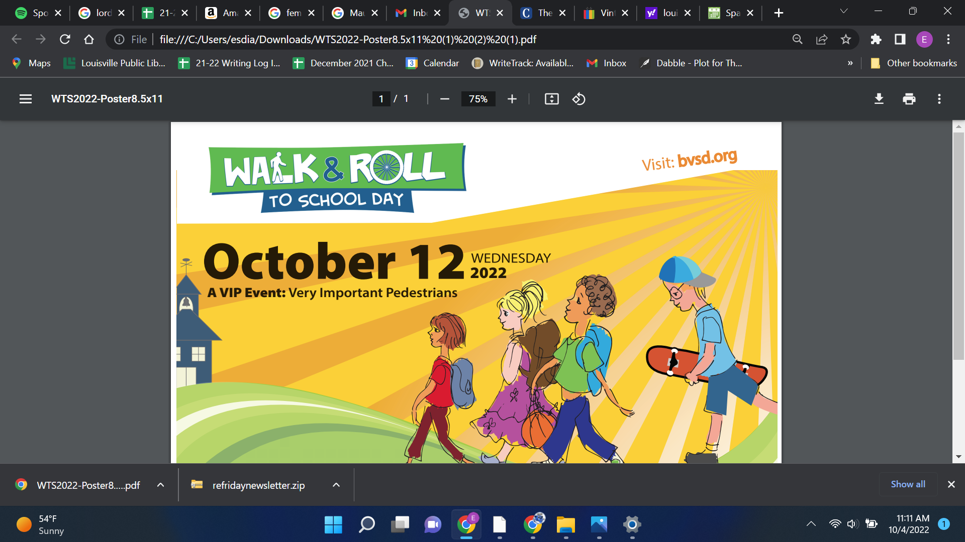
  ----------------------------------
  Sign Up Here to decorate or pass out goodies on Walk & Roll Day (Oct 12)
  PTO Meeting
  TUE, OCT 18, 2022 6 - 7 PM Virtual (Link TBD)
  Interim Principal Jeff VanIWarden will provide an update on school happenings. Also, hear about the Climate Action Group and Families & Educators Together (FET). Can’t make it? Video link will be posted to CoalCreekPTA.com Have Questions/Comments? Email Coal Creek Elementary PTA
Upcoming Events & Reminders

OCT 7 Silent Disco
OCT 10-14 Book Fair
OCT 12 Walk/Bike to School
OCT 18 PTA Community Meeting
NOV 14 Chipotle CCE Night


CHIPOTLE CCE Night
Stop into Chipotle on McCaslin between 4 - 8 PM on Monday, Nov 14 and they will donate a %of their proceeds to CCE.
Use the code D7YZ8L2 to order online.

Click Here to Become a PTA Member
www.CoalCreekPTA.com – Coal Creek PTA on Facebook – PTA Community Meeting Schedule

